**Instructions**

* Save your file as surnameforename.html.
* Use embedded style sheets.
* Once you have completed the exam, email your file to [anne.obrien@staff.ittralee.ie](mailto:anne.obrien@staff.ittralee.ie)
* Do not leave until I have received your exam.
* Please keep a copy of the exam until you get your results back.

**Screen Capture**

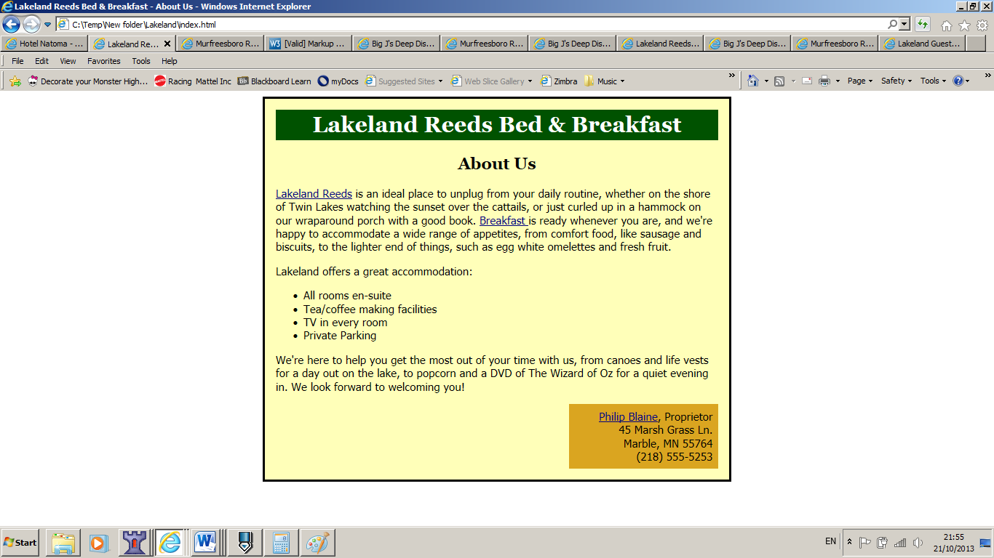

**Links**

[Philip Blaine](mailto:xx@yahoo.com) should link to a mail:xx@yahoo.com

Lakeland Reeds should link to: http://www.lakedistrictcottages.me.uk/

Breakfast: Based on the chart below and presuming you are in index.html, what would be the relative link to Breakfast.html

**Text**

# Lakeland Reeds Bed & Breakfast

## About Us

[Lakeland Reeds](http://www.lakedistrictcottages.me.uk/) is an ideal place to unplug from your daily routine, whether on the shore of Twin Lakes watching the sunset over the cattails, or just curled up in a hammock on our wraparound porch with a good book. Breakfast is ready whenever you are, and we're happy to accommodate a wide range of appetites, from comfort food, like sausage and biscuits, to the lighter end of things, such as egg white omelettes and fresh fruit.

Lakeland offers a great accommodation:

* All rooms en-suite
* Tea/coffee making facilities
* TV in every room
* Private Parking

We're here to help you get the most out of your time with us, from canoes and life vests for a day out on the lake, to popcorn and a DVD of The Wizard of Oz for a quiet evening in. We look forward to welcoming you!

[Philip Blaine](mailto:xx@yahoo.com), Proprietor  
45 Marsh Grass Ln.  
Marble, MN 55764  
(218) 555-5253

**Settings**:

Background colours used are #005200, #ffffb9, #daa520

Headings font: georgia, "times new roman", times, serif

Box font: tahoma, arial, helvetica, sans-serif

Text colour : #005200

Headings size 32 and 24

Main box has a width of 640px